MGS 616 - Predictive Analytics
HW3
Submitted by: Group 3
Daniel Charles
Jack Foley
Simran Pahuja
Khoi Nguyen Do Phan

1.
About the dataset:
- Toyota Corolla dataset has 39 columns and 1436 rows in total. We saw that most of the data types are binary and a few of them contain numeric and categorical variables.
- No missing values were found in the dataset, so there was no need for omission or imputation to be done in the dataset before the analysis.
- In order to do the summary statistics and to ensure appropriate handling of the dataset in the modeling, we converted the three categorical variables namely Fuel_Type, Color and Model into factors, where each character is converted into levels.
An overview of the summary statistics:
- A wide range of car values is shown by the price, which ranges from €4,350 to €32,500 with an average of about €10,731.
- Age & KM: Most of the cars are 56 months old and have about 68,000 kilometers on them on an average.
- Fuel Type: Most of the vehicles in the datasets are petrol-powered, followed by diesel and a few CNG vehicles.
Visual Perspectives:
- Fuel Type Distribution: Petrol has highest count in the fuel type, according to a bar chart.
- Price by Fuel Type: If we see the boxplot, compared to gasoline or CNG, diesel vehicles typically have higher median prices and greater variability.
- Correlation: There are many significant relationships between variables. For example, Age_08_04 has a strong positive with KM at 0.87, possibly meaning that older cars have more kilometers and vice versa, or HP has a strong positive with quarterly_tax at 0.74 as more horse powers, more taxes got to pay. Furthermore, Age_08_04 has a strong negative with guarantee_period at -0.76 as new cars have longer guarantee period while old ones have less period. Moreover Mfg_year and price also show strong correlation of 0.89.
- For the plot distributions, we can clearly see that most distributions have only 2 columns at the values of 0 or 1 due to binary type. Only some plots that contain numeric data type have a distribution. For example, KM, Price, and Age_08_04. KM and Price have the right skew distribution while Age_08_04 has a left skew distribution. All of them have outliers either at the end of the left or at the end of the right.

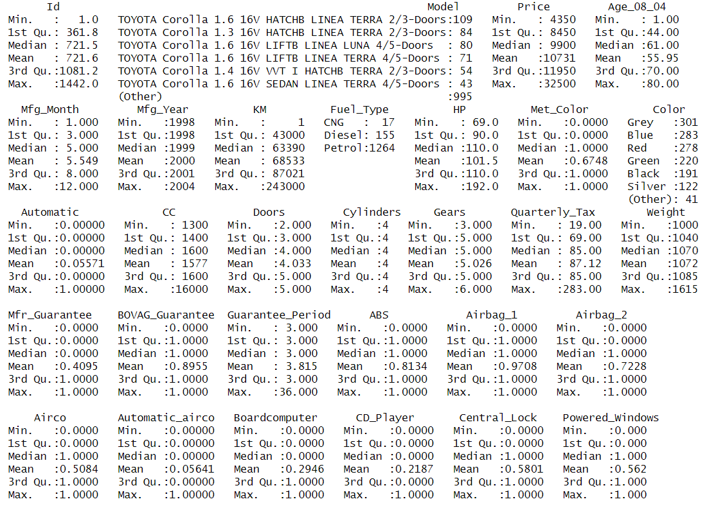
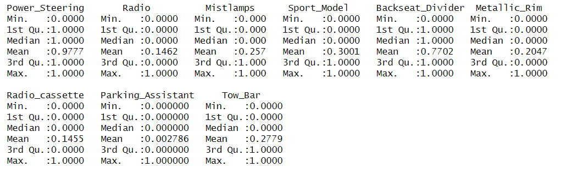
Fig1: Summary Statistics

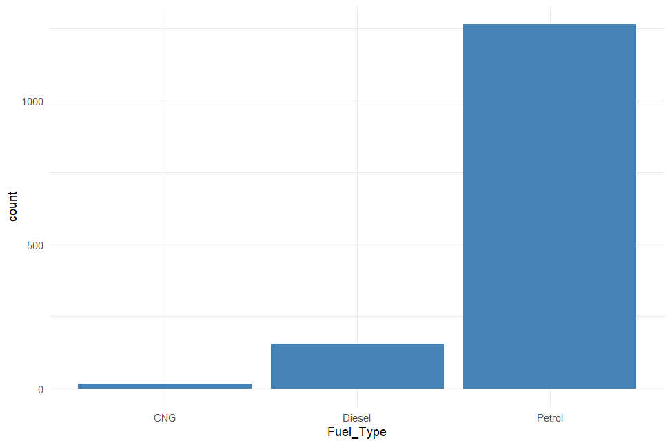
Fig2: Fuel Type Bar Plot

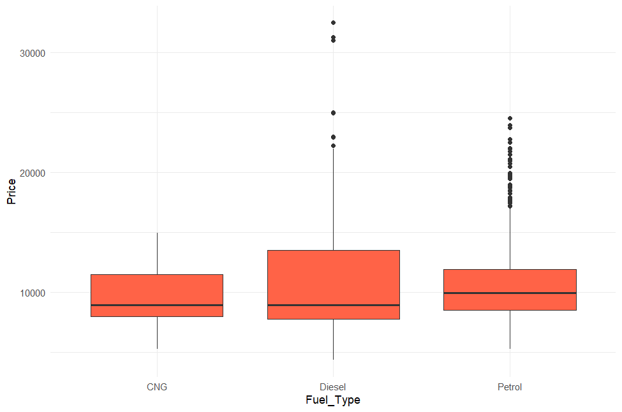
Fig3: Price vs Fuel Type Boxplot

Fig4: Heatmap
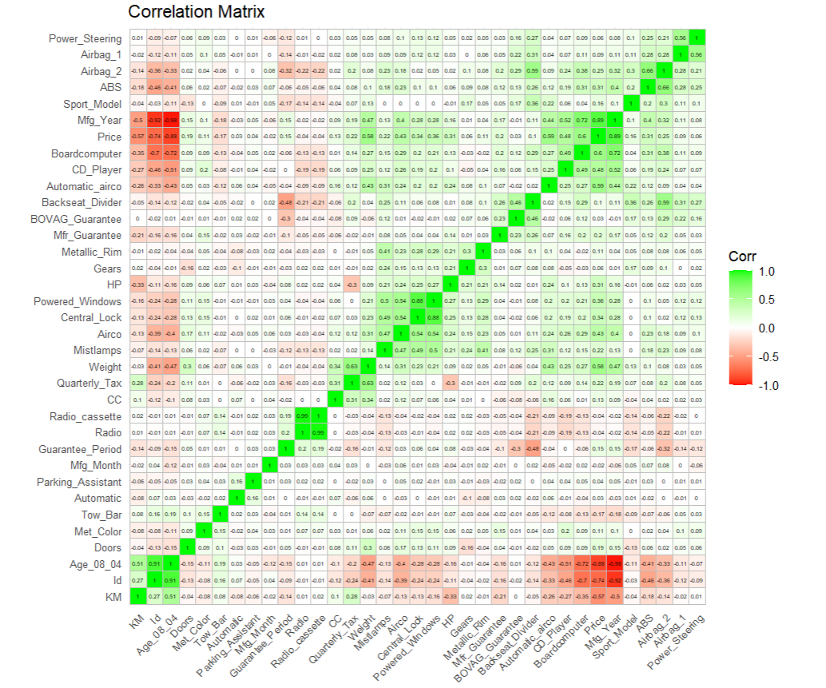

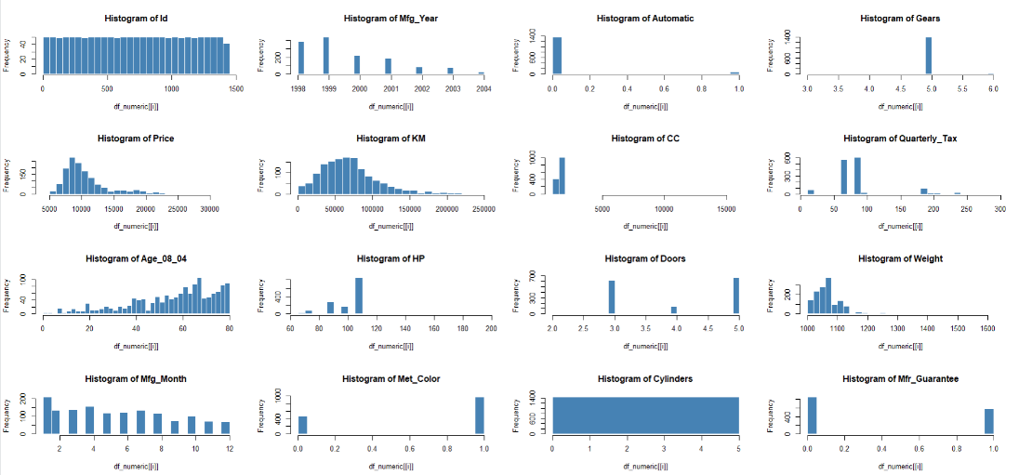
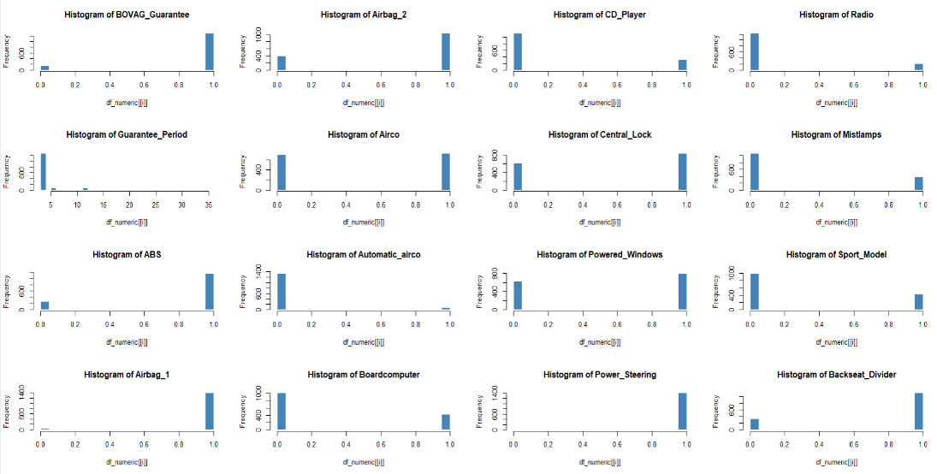
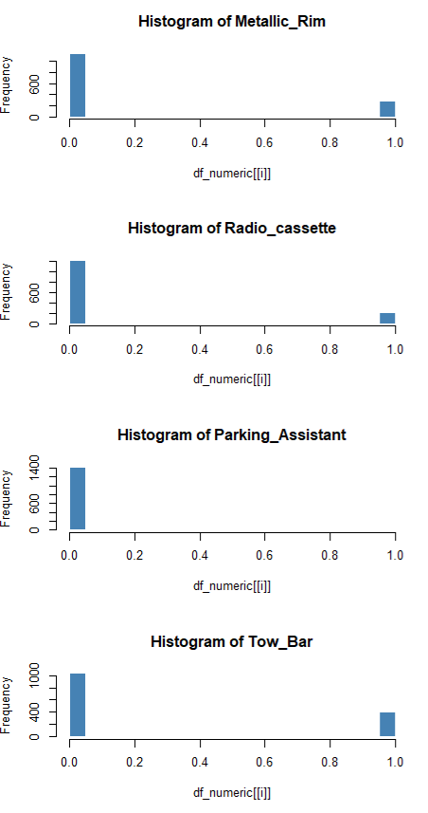
Fig5: Histogram

Boxplot
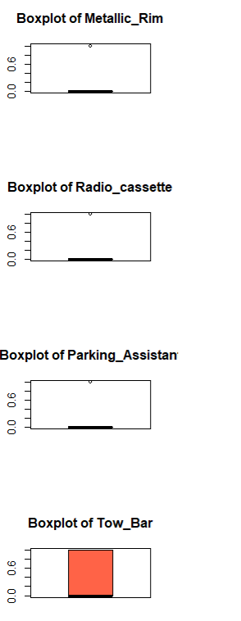
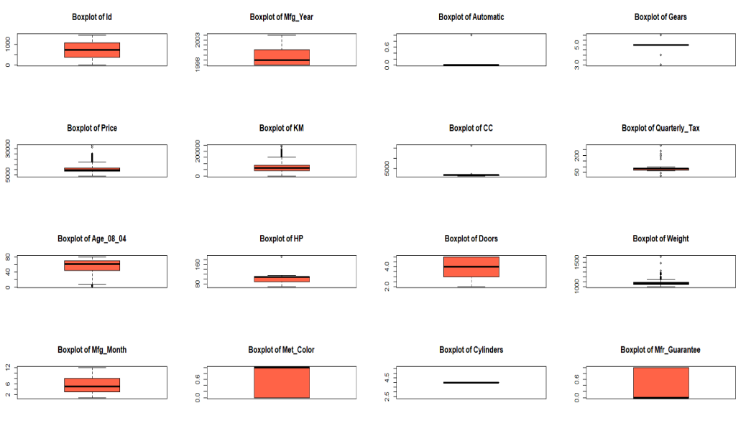
Fig6: Boxplot
2.
In this part, we have split the dataset into 60% training and 40% validation sets using seed 16. A multiple linear regression was built using 16 predictors to understand which ones are explaining the variability in target variable at its best. The model achieved the R -squared value of 88%, which means that the predictors explain 88% variation in car prices. Most of the predictors were found to be statistically significant with low p-values and high t-values.
3.
a. Top 4 most important car specifications for the car’s price are Age_08_04, KM, Automatic_airco, and HP. We can identify that by looking at the largest absolute t values and lowest p values for each variable. For example, Age_08_04 has a t value of -30.918 and p value is smaller than 2e-16 or Automatic_airco has t value of 13.524 and p value is also smaller than 2e-16. Same thing with other variables.
b. Based on the visual assessment, residuals seem to spread more as fitted values increase, leading to not perfectly constant variance. This means that the data appear heteroscedastic. Using Breusch-Pagan test, BP = 154, df = 16, and p value is almost zero, showing the evidence of heteroscedastic.
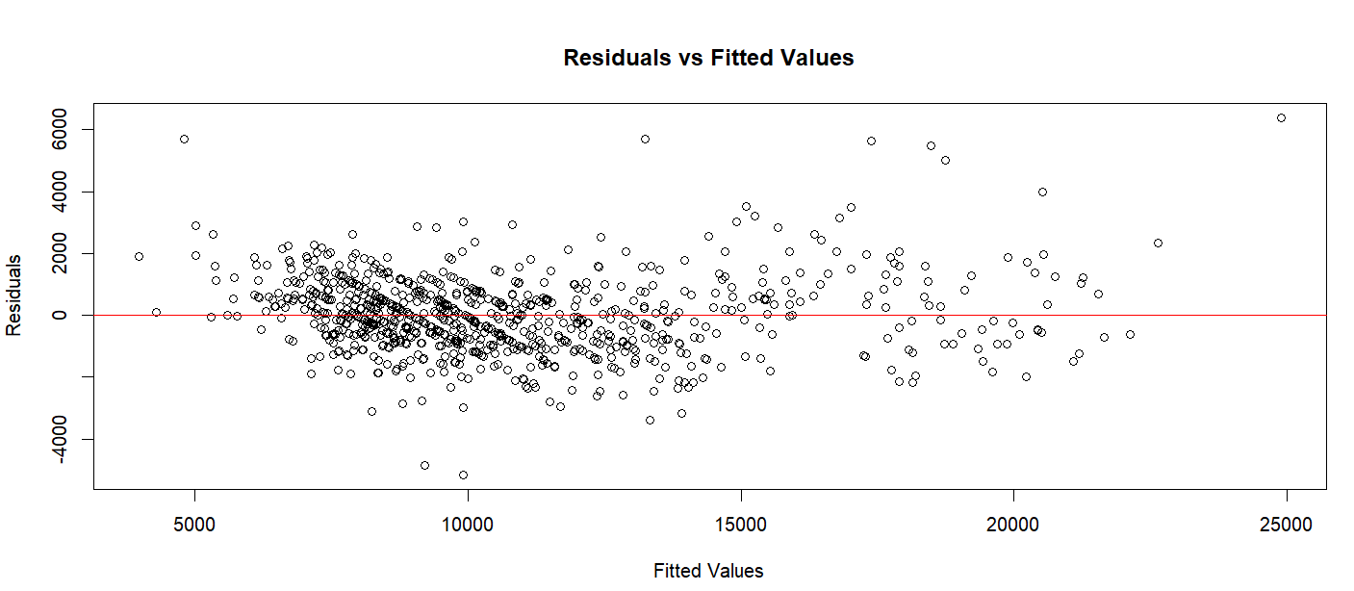
Fig7: Plot for Residuals

c. RMSE and MAE are very close to the training set, indicating that the model accuracy is good and shows no sign of overfitting. Additionally, ME and MPE are close to zero, meaning that there is no significant bias in over prediction or under prediction. MAPE also shows strong accuracy.
d. Accuracy of complex models is more as the metrics RMSE, MAE, MAPE are lower as compared to simpler models. But the simpler model is easier to interpret due to a smaller number of predictors. So, if our goal is to maximize predictive accuracy, we should go with the complex model and if we want a more interpretable model, the simpler one is good to go for instead.
Our recommendation would be to go for Model with 16 predictors (complex model) as it has higher R-squared and adjusted R-squared value with feature richness. Higher accuracy and lower error metrics i.e., RMSE, MAE and MAPE compared to simple model. As the model training and validation errors are consistent, it shows that there is no overfitting when including large number of predictors.

